Experiment 1-Comparative Analysis: Traditional Development vs Low-Code Development

DEVISHREE J

240701702

1. Aim
The aim of this comparative analysis is to evaluate the Traditional Software Development approach and the Low-Code Development approach based on their development process, speed, cost, flexibility, maintenance, and overall efficiency. This comparison helps organizations select the most appropriate development method according to their project requirements.

2. Introduction to Traditional Approach
The Traditional Software Development approach is the conventional method of building software applications through manual programming using languages such as Java, C#, Python, or C++. Developers write source code from scratch and follow a structured Software Development Life Cycle (SDLC), including planning, designing, coding, testing, deployment, and maintenance.

Features of Traditional Development:
- Manual coding is required.
- Complete control over application design and functionality.
- Highly customizable.
- Suitable for complex and large-scale applications.
- Requires experienced software developers.

Advantages:
- High flexibility and customization.
- Better performance optimization.
- Suitable for enterprise-level applications.
- Greater control over security and architecture.

Disadvantages:
- Longer development time.
- Higher development cost.
- Requires skilled programmers.
- Maintenance can be time-consuming.

3. Introduction to Low-Code Approach
The Low-Code Development approach uses visual development tools, drag-and-drop interfaces, and pre-built components to create applications with minimal manual coding. It enables both professional developers and business users (citizen developers) to build applications quickly.

Features of Low-Code Development:
- Visual drag-and-drop interface.
- Minimal coding.
- Reusable components and templates.
- Faster application development.
- Easy integration with databases and APIs.

Advantages:
- Rapid application development.
- Lower development cost.
- Faster deployment.
- Easier maintenance.
- Increased productivity.

Disadvantages:
- Limited customization for complex applications.
- Vendor/platform dependency.
- Licensing costs may apply.
- Less suitable for highly specialized software.

4. Diagram for Stages in Traditional and Low-Code Development

Traditional Software Development Stages:
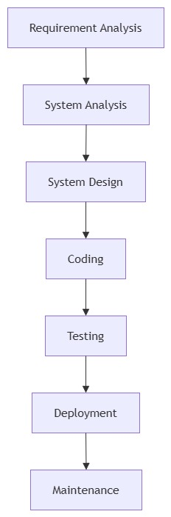

Low-Code Development Stages:
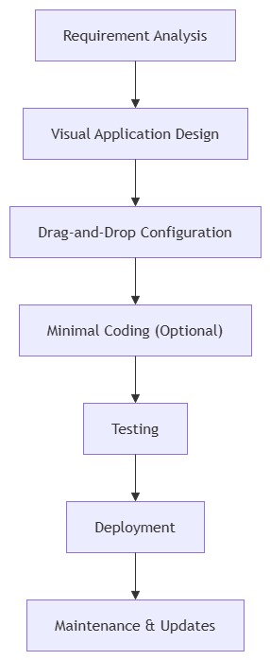

5. Comparison Between Traditional and Low-Code Development

Aspect | Traditional Development | Low-Code Development
Development Method | Manual programming | Visual development with minimal coding
Coding Requirement | High | Low
Development Speed | Slow | Fast
Development Time | Weeks to months | Days to weeks
Cost | Higher | Lower
Customization | Very high | Moderate
Ease of Use | Requires expert developers | Easy for developers and citizen developers
Flexibility | Very flexible | Limited by platform capabilities
Maintenance | More complex | Easier and faster
Deployment | Time-consuming | Quick deployment
Productivity | Moderate | High
Best Suited For | Large, complex, and customized applications | Business applications, workflow automation, and rapid prototyping

6. Result
Thus, the comparative analysis between Traditional Software Development and Low-Code Development was successfully completed. It was observed that Traditional Development provides greater flexibility, customization, and control for complex applications, whereas Low-Code Development enables faster application development with lower cost and minimal coding effort. The appropriate development approach depends on the project requirements, budget, complexity, and development time.

